Terraform task - 02

- Watch the Terraform-02 video. Video completed
- Execute all the templates shown in the video.
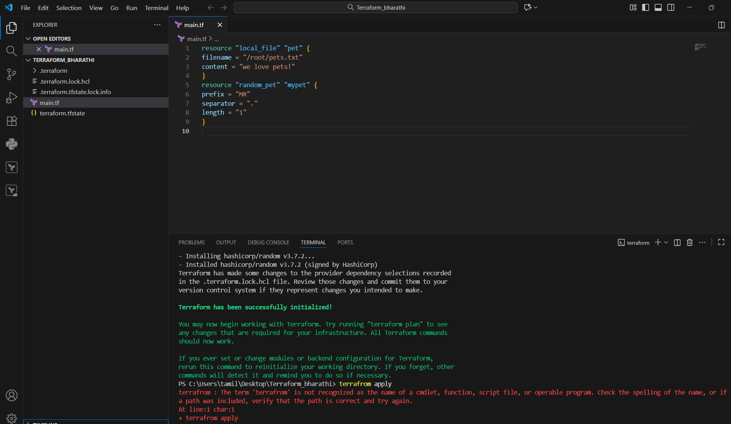
Terraform.tfstate => the state file that Terraform uses to keep track of the real-world infrastructure it has created
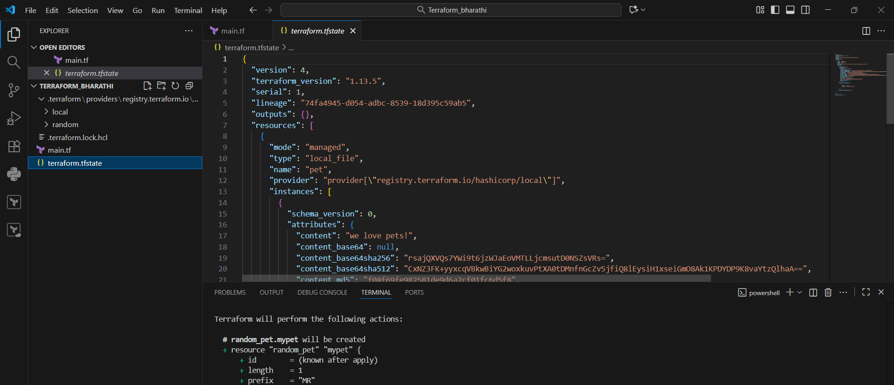
- Integrate Terraform in Jenkins using the Terraform plugin.
1. Install the Terraform Plugin in Jenkins:
- Navigate to "Manage Jenkins" > "Manage Plugins."
- Go to the "Available" tab and search for "Terraform."
- Select the "Terraform" plugin and click "Install without restart" or "Download now and install after restart."
- Ensure the plugin is enabled after installation by checking the "Installed" tab.

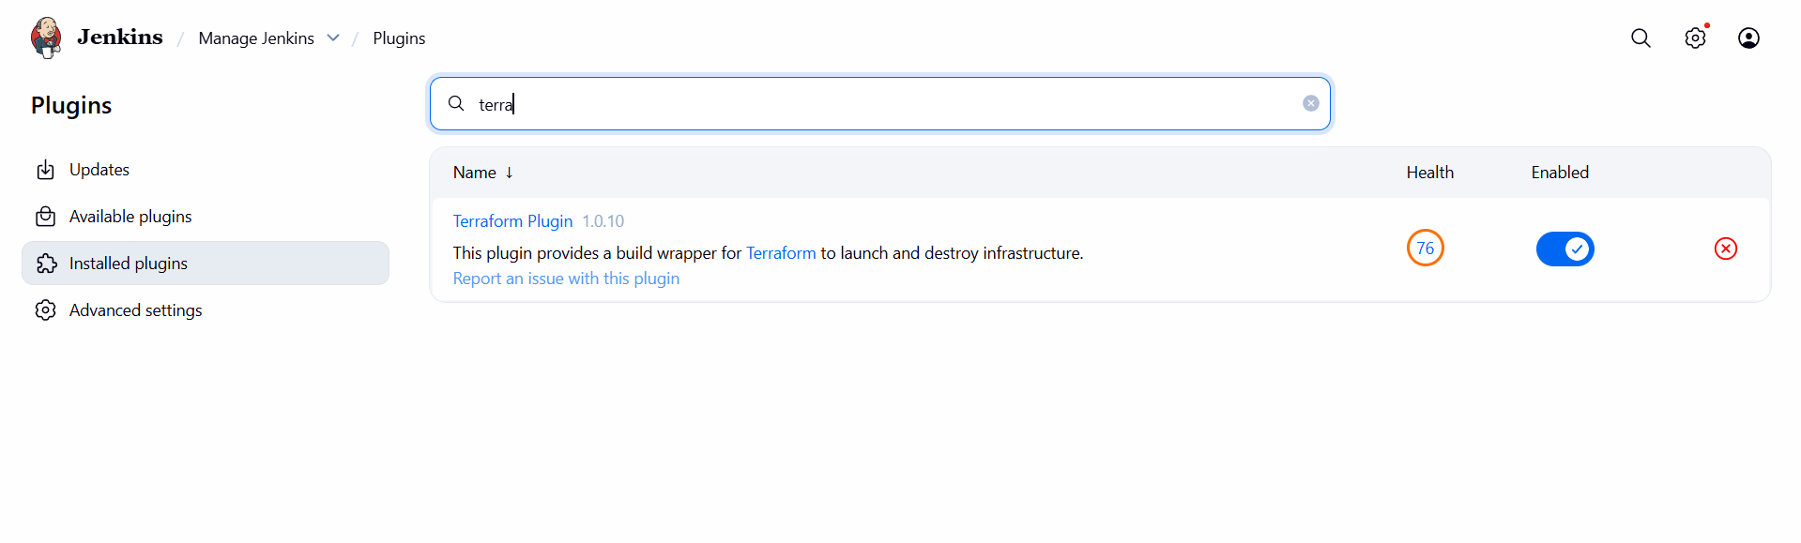
2. Configure Terraform Installations in Jenkins:
- Go to "Manage Jenkins" > "Global Tool Configuration."
- Locate the "Terraform" section and click "Terraform installations..."
- Click "Add Terraform" and provide a name for the installation.
- You can choose to install automatically or provide the path to an existing Terraform binary if installed manually on the Jenkins agent.
Git clone link download the source code to our EC2 Jenkins servers
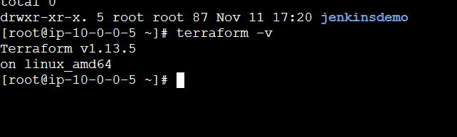
Create terraform_plugins

AWS credential install
STEP 2 — Install Terraform Plugin in Jenkins
- Go to Manage Jenkins → Manage Plugins → Available
- Search Terraform
- Install “Terraform Plugin”
- Restart Jenkins once.

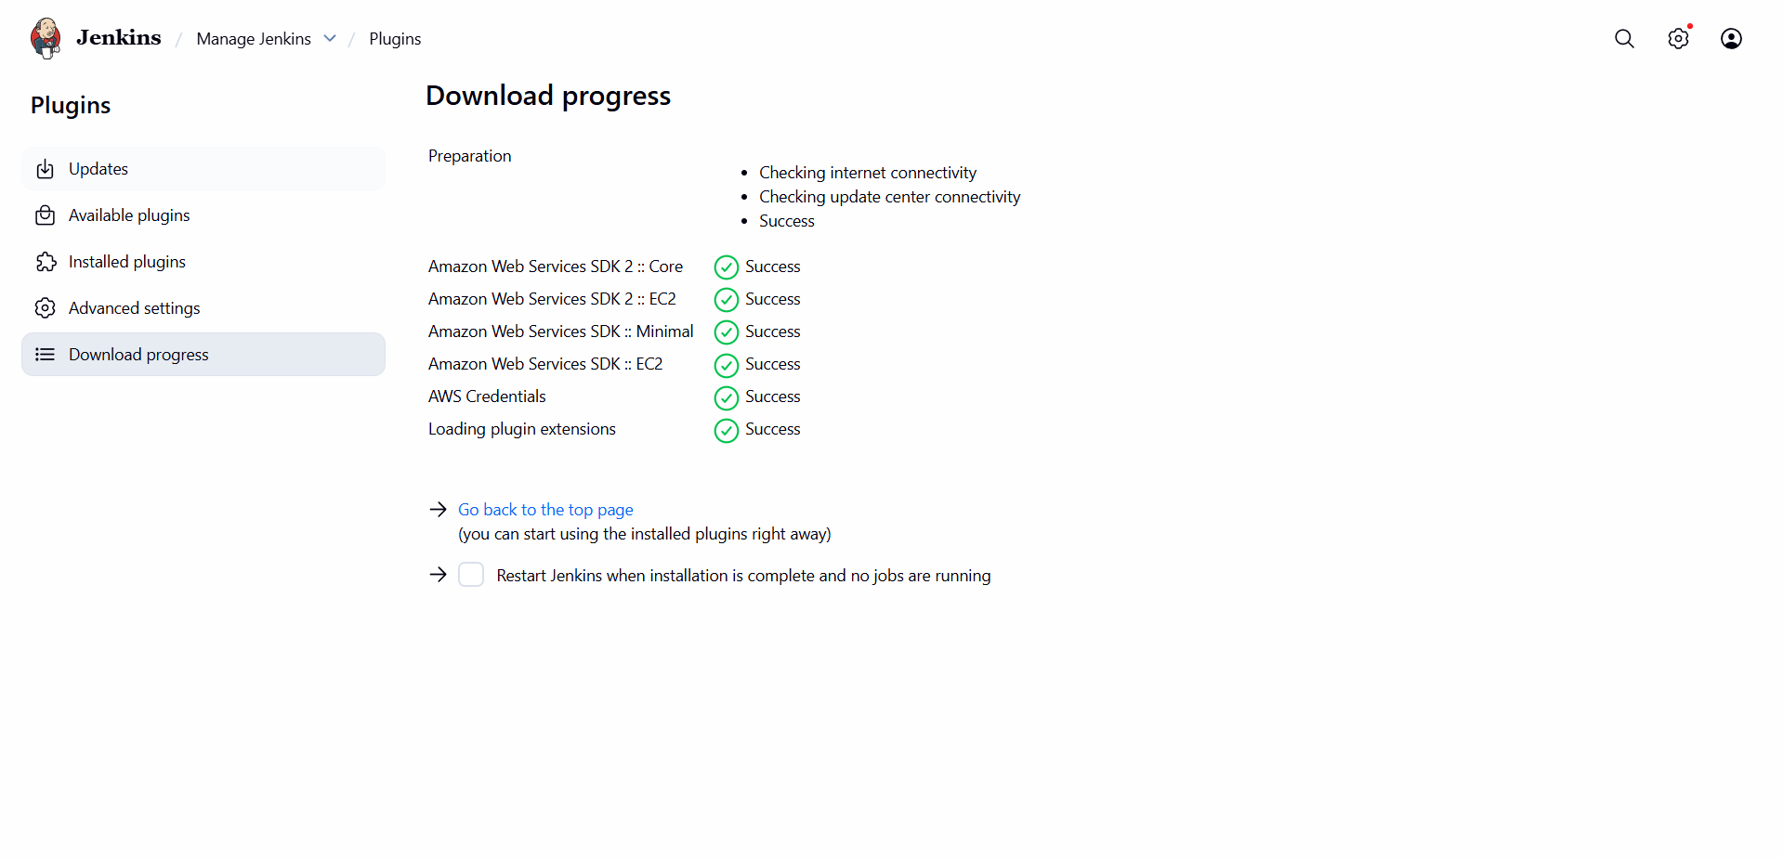
STEP 3 — Add AWS Credentials in Jenkins
- Go to Manage Jenkins → Credentials → System → Global credentials
- Click Add Credentials
- Choose:
  - Kind: “Username with password”
  - Username: your AWS Access Key
  - Password: your AWS Secret Key
  - ID: aws-creds
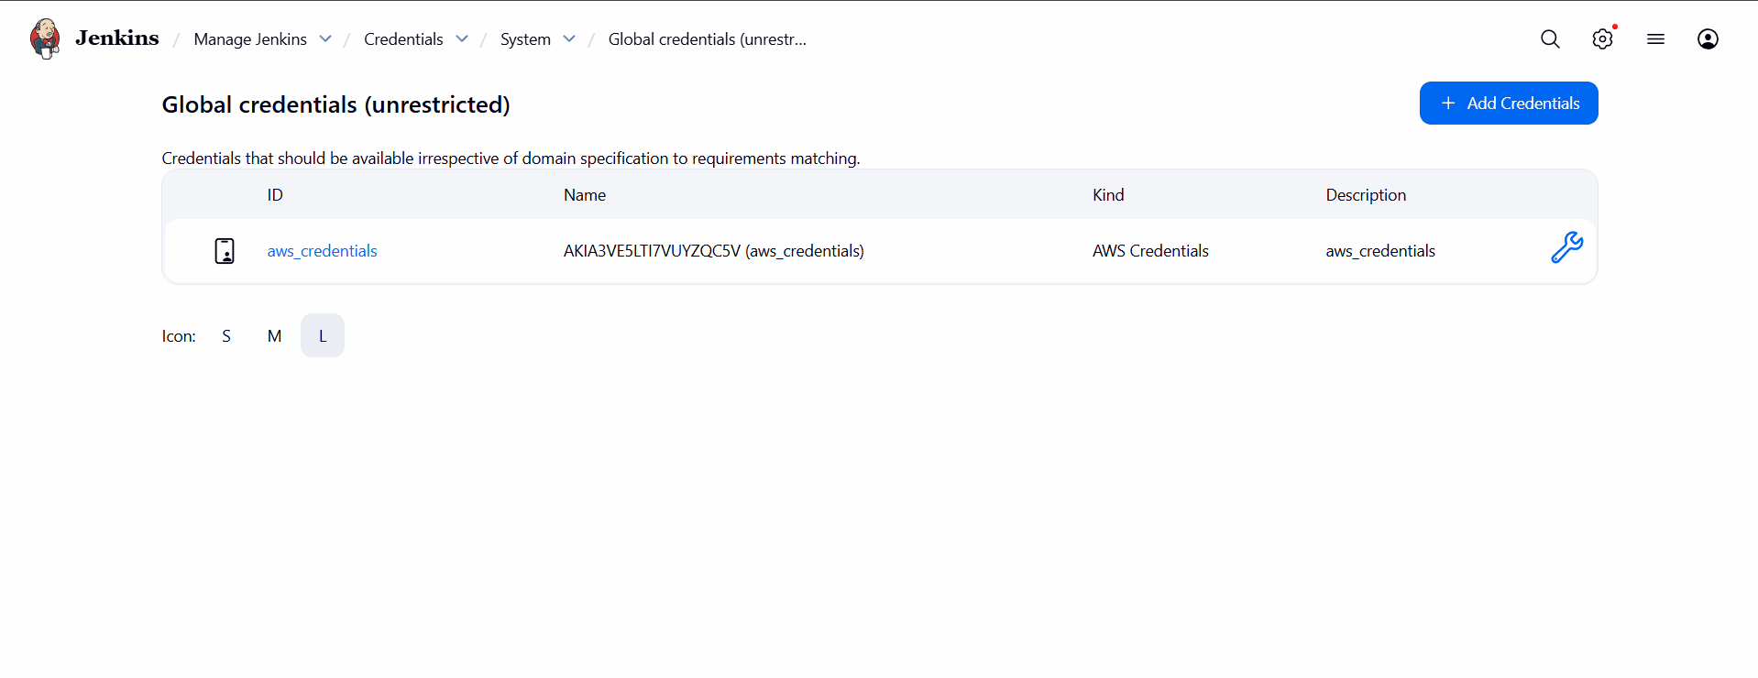
Create a Jenkins Pipeline Job
- Go to Jenkins Dashboard
- Click New Item
- Type a name → e.g. Terraform-Pipeline
- Select Pipeline → click OK
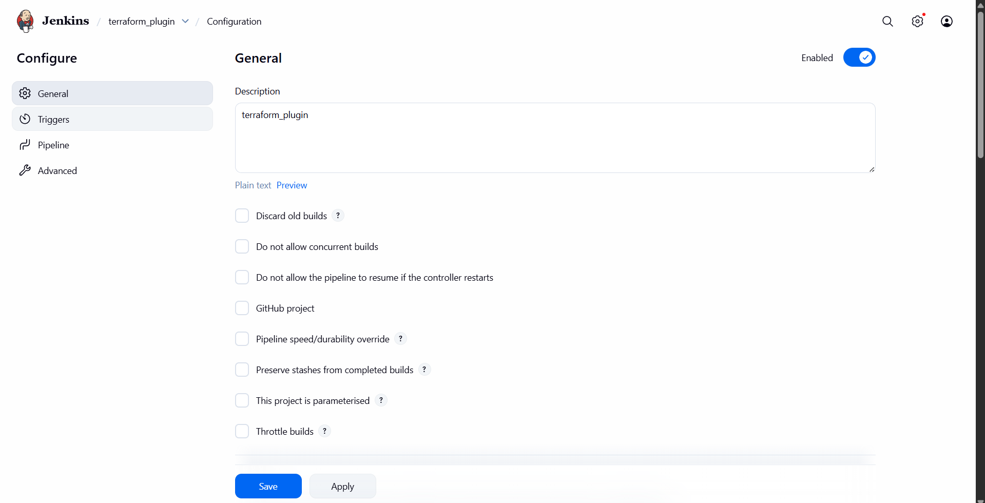

STEP 5 — Add your GitHub Repository
- In your GitHub, make sure you have these files:
terraform1/
├── main.tf
├── provider.tf
├── variables.tf
├── output.tf
├── Jenkinsfile
Your Jenkinsfile must be in the root folder of your repo (very important)
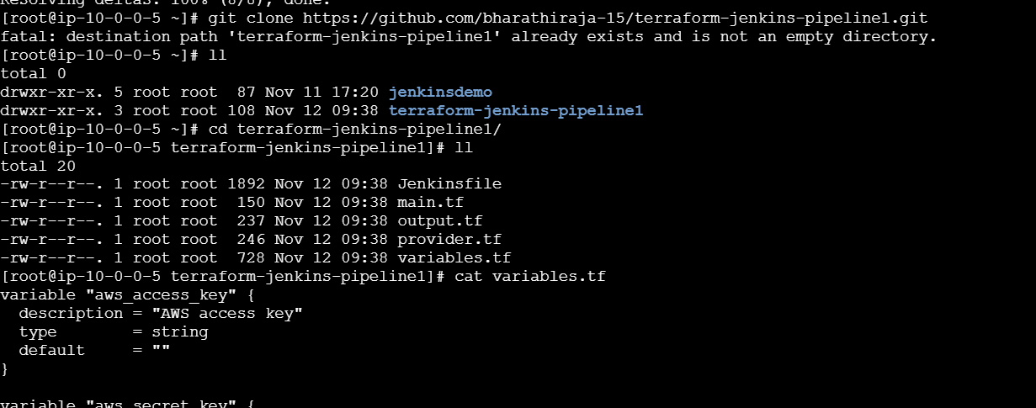
Configure Pipeline in Jenkins
In your Jenkins job:
- Go to Configure
- Scroll to Pipeline
- Select Definition: Pipeline script from SCM
- Choose:
  - SCM: Git
  - Repository URL: your repo (e.g. https://github.com/bharathiraja-15/terraform1.git)
  - Branch: main
  - Script Path: Jenkinsfile (default)
- Save
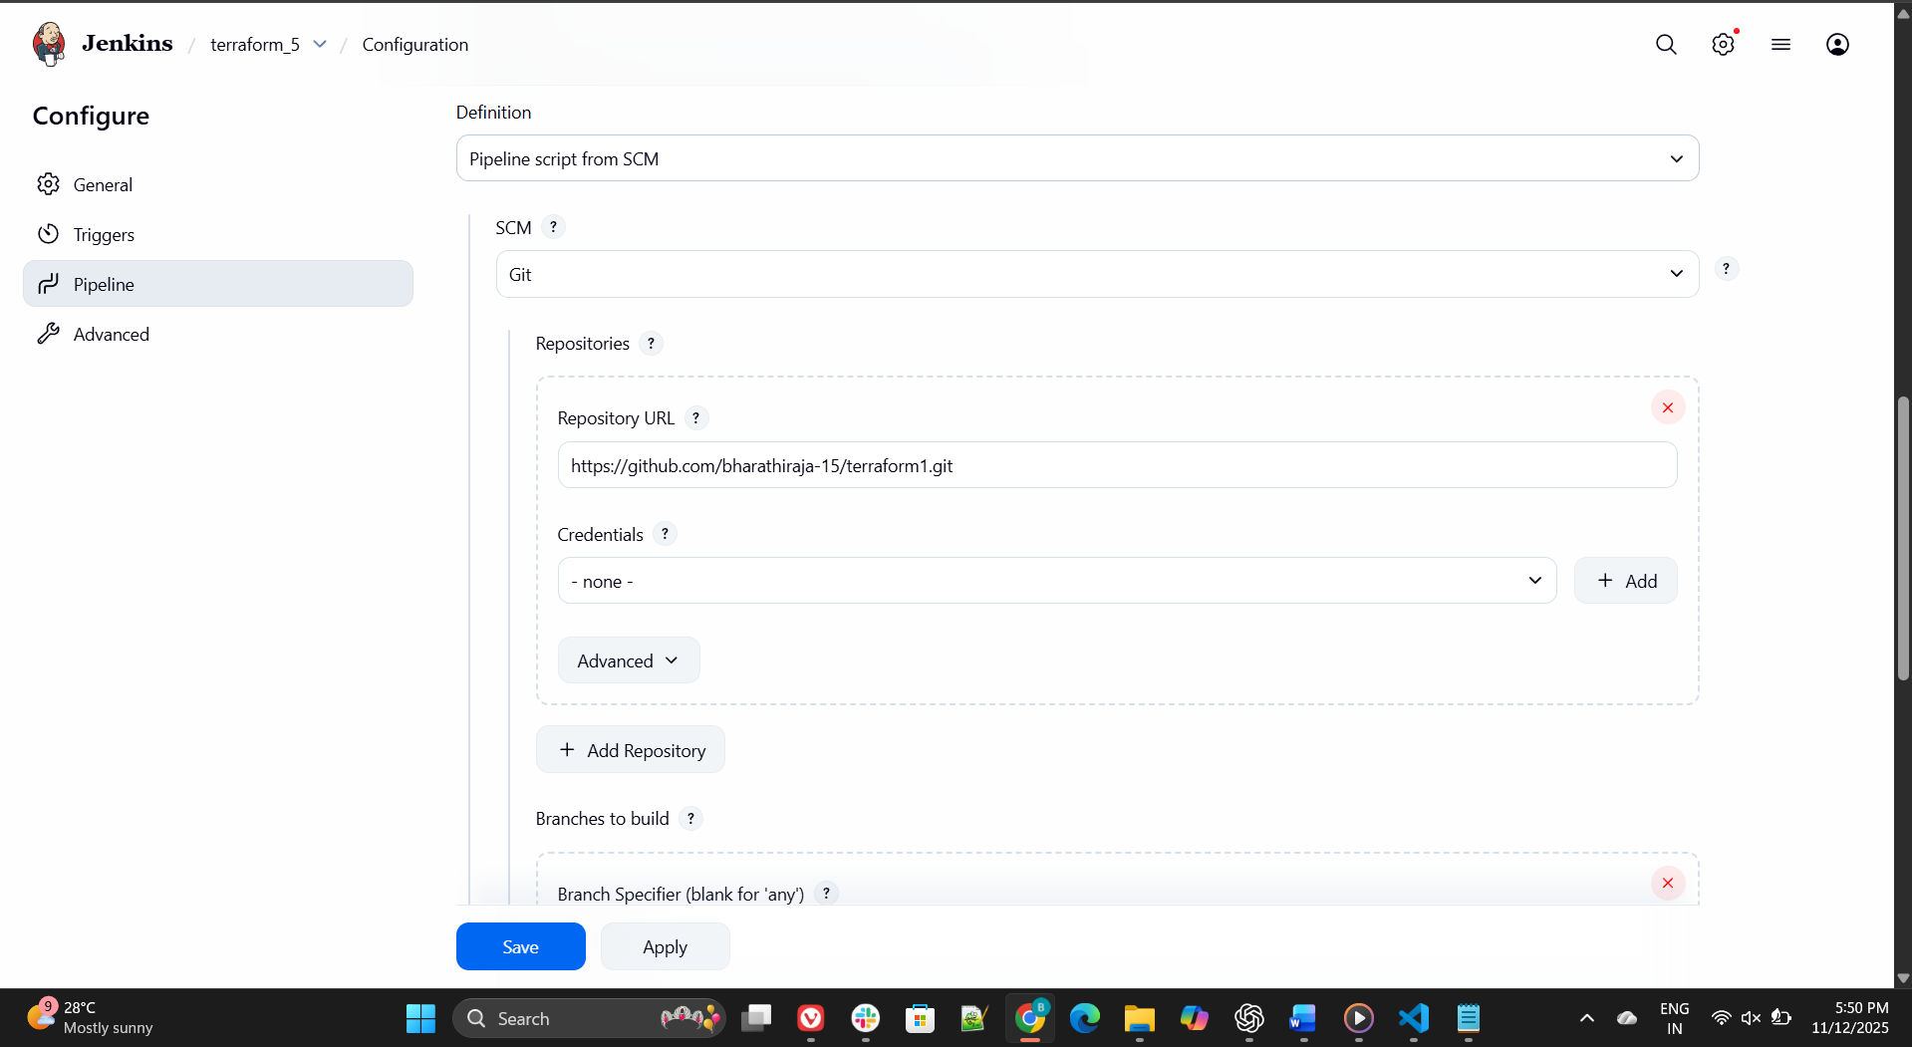
Run the Pipeline
- Click Build Now
- Jenkins will:
  - Clone your GitHub repo
  - Run terraform init
  - Run terraform plan
  - Ask your approval
  - Run terraform apply
✅AWS instance will be created.

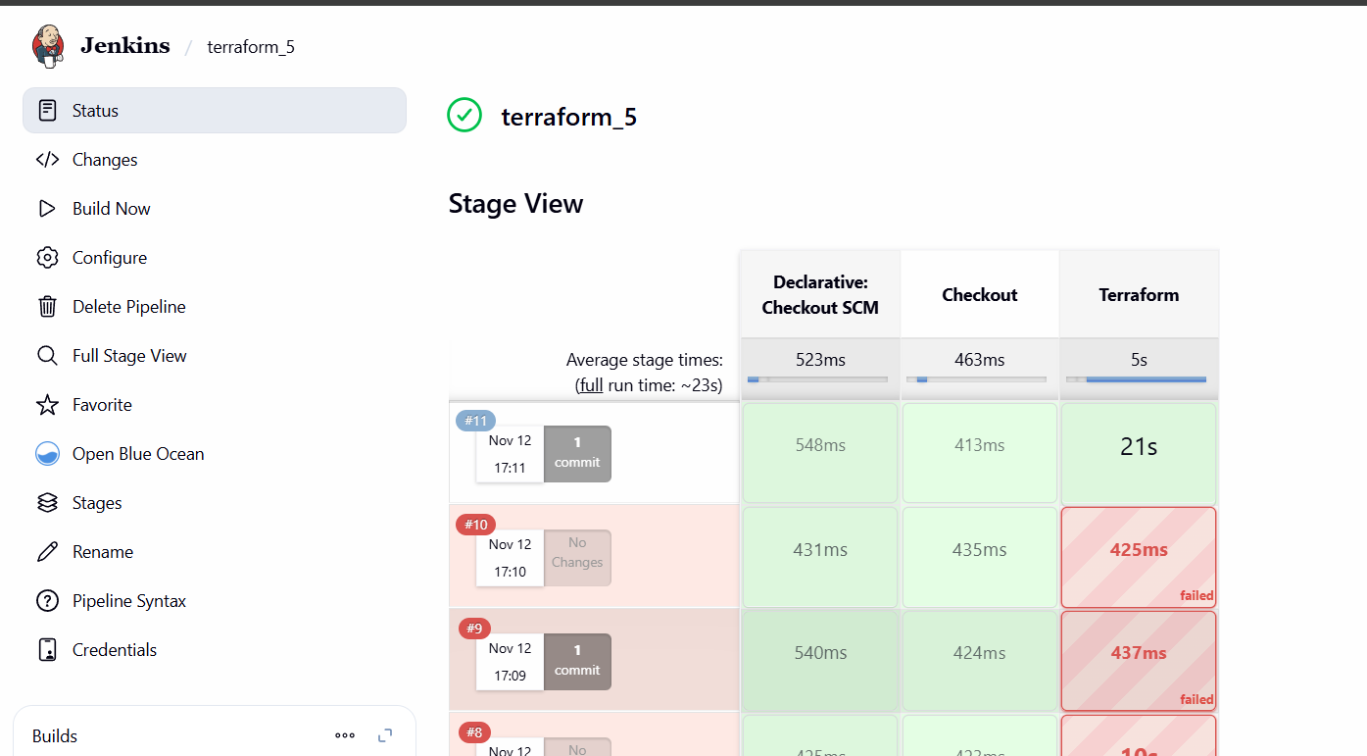
I got the Terraform instance
✅ AWS instance will be created.
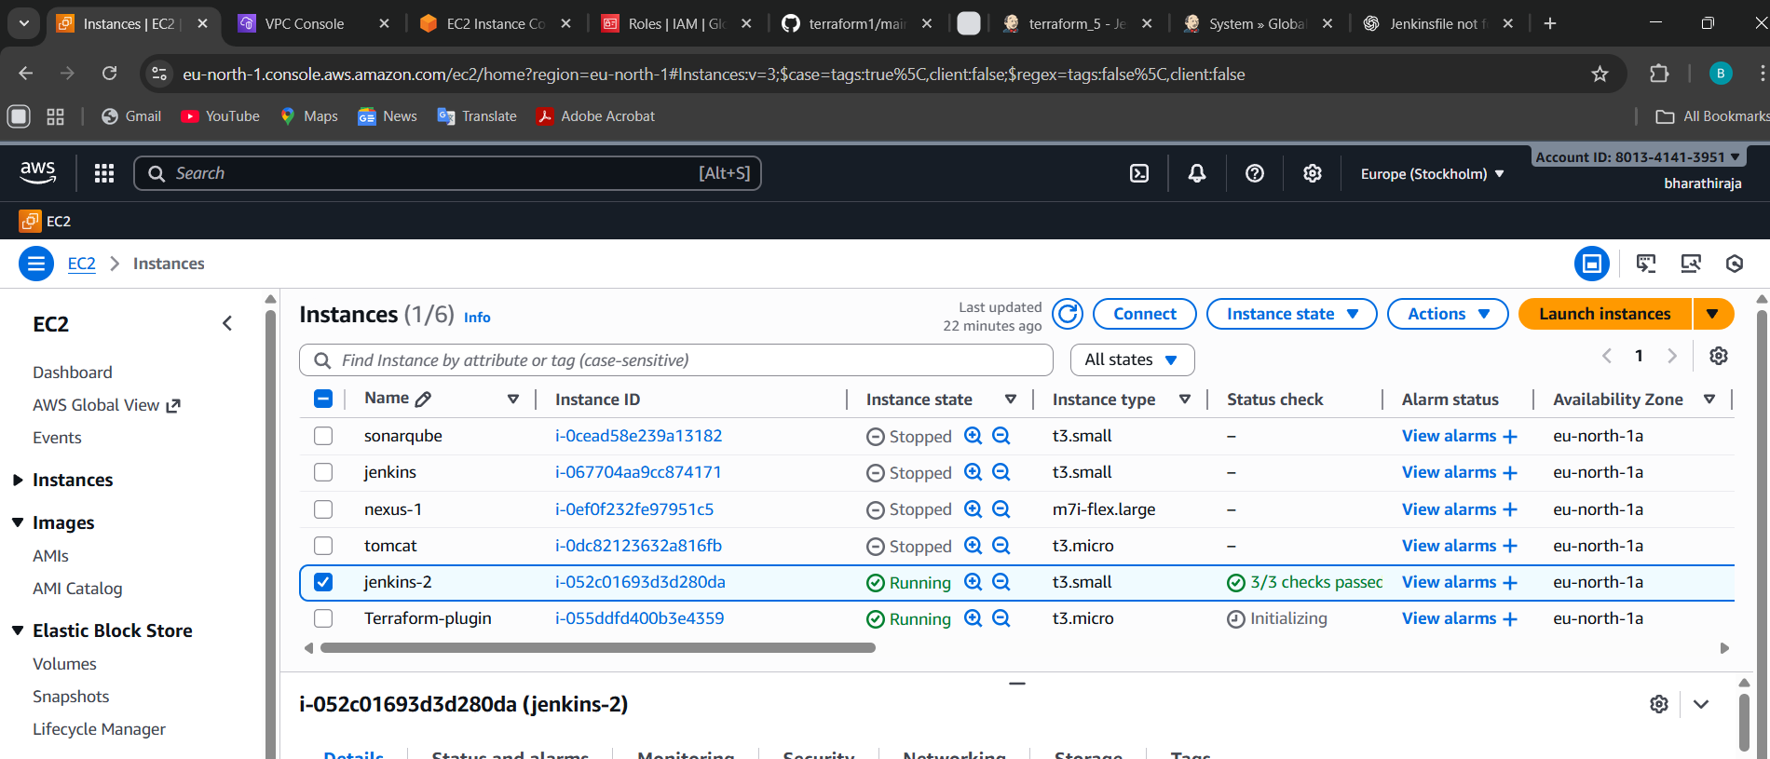
Summary
Step | Action
1 | Install Terraform
2 | Install Terraform plugin
3 | Add AWS credentials
4 | Create pipeline job
5 | Add Jenkinsfile to GitHub
6 | Run pipeline → Terraform creates AWS instance

